Claude White

Math for Computer Science

PEA Project

1.

x = x1 - x0 = 14 - 9 = 5

y = y1 - y0 = 22 - 18 = 4

M = $Δ$ y / $Δ$ x = 4 / 5 = 0.8

|x| > |y| then define steps = |x| = 5

M < 1 so {xp+1 = 1 + xp

{yp+1 = M + yp

|  |  |  |  |
| --- | --- | --- | --- |
| n | xn | yn | graph point |
| 0 | 9 | 18 | (9,18) |
| 1 | 10 | 18.8 | (10,19) |
| 2 | 11 | 19.6 | (11,20) |
| 3 | 12 | 20.4 | (12,20) |
| 4 | 13 | 21.2 | (13,21) |
| 5 | 14 | 22 | (14,22) |

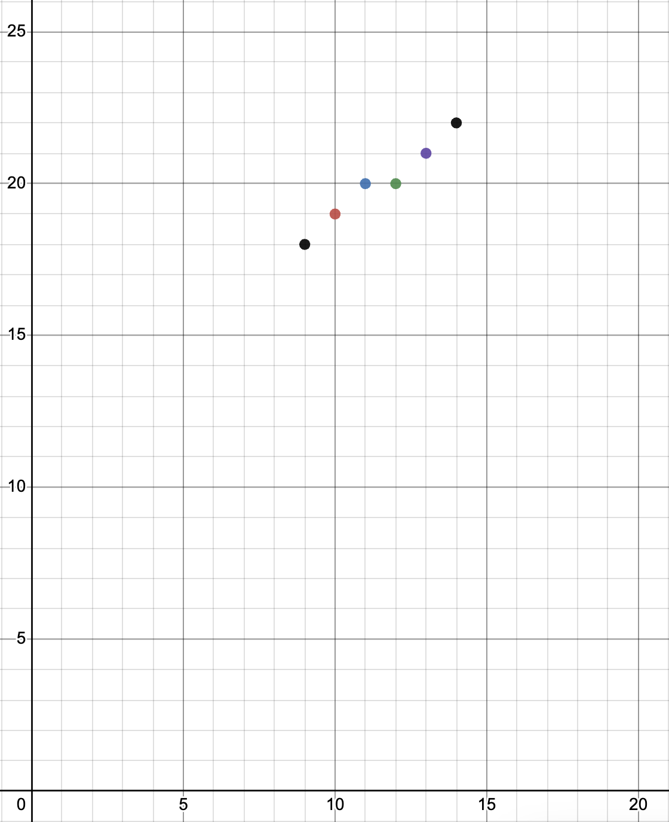

2.

x = x1 - x0 = 14 - 9 = 5

y = y1 - y0 = 22 - 18 = 4

Pk = 2 $Δ$ y - $Δ$ x = 8 - 5 = 3

Pk < 0 {Pk + 1 = Pk + 2 $Δ$ y

{xk+1 = 1 + xk

{yk+1 = yk

Pk >= 0 {Pk + 1 = Pk + 2 $Δ$ y - 2 $Δ$ x

{xk+1 = 1 + xk

{yk+1 = 1 + yk

|  |  |  |  |  |
| --- | --- | --- | --- | --- |
| n | xn | yn | Pk | Graph Point |
| 0 | 9 | 18 | 3 | (9,18) |
| 1 | 10 | 19 | 1 | (10,19) |
| 2 | 11 | 20 | -1 | (11,20) |
| 3 | 12 | 20 | 7 | (12,20) |
| 4 | 13 | 21 | 5 | (13,21) |

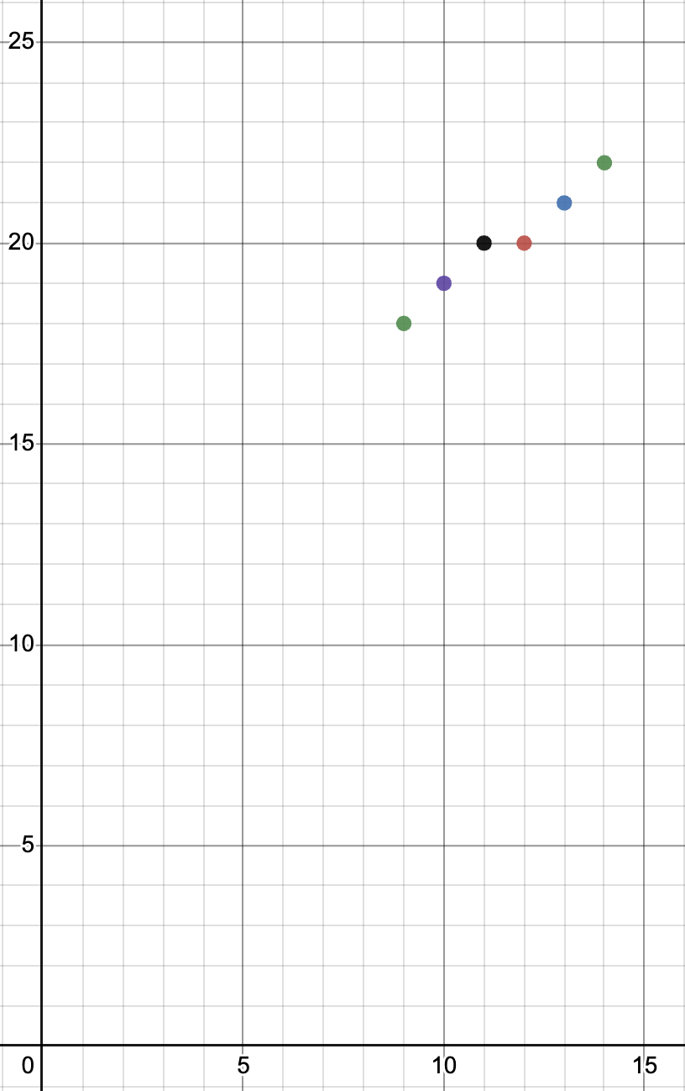

PEA Paragraph

In the second chart I used the Bresenham line drawing algorithm. Some of the advantages I found with this algorithm is that it is easy to implement because it only uses integer calculations and the points generated are accurate. This algorithm also has some disadvantages as well. The lines generated are not smooth, this algorithm ignores anti-aliasing which is supposed to smooth jagged lines in digital images. I learned more about the Bresenham algorithm because I had to go and learn it on my own and at my own pace. Then we reviewed in class made sure I understood the algorithm, but I did enjoy this take on learning. At the same time I fell down some rabbit holes while researching so in the end I learned even more than expected which was really nice for a change.

I also found a field of computer science that uses these types of algorithms and computer graphics is an animator, in my case a 2D animator. A 2D animator is a developer in graphic images that simulates a movement by using frames, all of this in 2D space. Line drawing algorithms are used by the program the 2D animator uses to create the lines he draws on his device. Better line drawing algorithms are required, because of the need for beautiful lines and smooth edges in their animations. For example, some line drawing algorithms are used by the software a 2D animator working at Aristocrat Technologies Inc uses Unity. A program that deals with 3D and 2D graphics. Line drawing algorithms are used to generate the lines and shapes created by the animators.

Reference: <https://ca.indeed.com/viewjob?jk=241ff1f0aa7220de&utm_campaign=google_jobs_apply&utm_source=google_jobs_apply&utm_medium=organic>